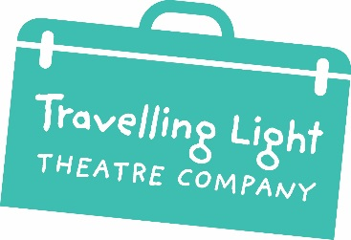

Barton Hill Settlement
43 Ducie Road, Barton Hill, Bristol BS5 0AX

Tel: 0117 377 3166
email: info@travellinglighttheatre.org.uk www.travellinglighttheatre.org.uk

Work Experience Application Form

PLEASE FILL IN ALL SECTIONS OF THIS FORM

This form is used to collect personal information. Data on this form is strictly confidential, please see our Privacy Statement below.

CONTACT DETAILS
Name of applicant
Date of birth
Address
Telephone number

Email address

Parent/guardian
(name & details)
Parent/guardian contact
(number)
EDUCATION…
Where are you studying?
Who is your main teacher?
Their contact details?
What are you studying?

ABOUT YOU
WHY would you like to do a placement with Travelling Light?
WHAT do you hope to do once you’ve finished a placement?

PRIVACY STATEMENT
To inform you why we collect your personal information and that of your child.

How we use your information: Most of the information within this form is essential to run our service, and is collected under the lawful basis of CONSENT. We need to know your age to place you into the right service, and we need contact information for you and parent/guardians to let you know essential information about the service.

How we store your information: All information given on this form is strictly confidential. We have restricted access controls for both printed/paper and digital documents, as per our Data Protection policy. We never share personal contact information with third parties without consent. Unless you object, personal information is kept for a period of 3 years. This is to allow us to track those who re-engage and also to identify pathways through Travelling Light services.

Your rights: You have the following rights under the General Data Protection Regulations 2018: Right to withdraw consent, right to object, right to correction, right to deletion, right to access.

Who to contact: If you have any queries regarding how we use your data, please contact the Creative Learning Officer: cl.officer@travellinglighttheatre.org.uk

